Do your work in Jupyter Python and screenshot your code with answers and paste the codes/answers below each question in this word document.

Submit both the word document and Python file. Include your name towards the end of this file name. For example: STAT L2 In-Class_Exercise_Neba_Nfonsang

1. Read in values from STATL2Sales.csv file. This data has information about our sales employees. The columns are shown:

* **First** – First Name
* **Last** – Last Name
* **Gender** – M or F
* **Job** – Job Title
* **Country** – Location they are responsible for
* **NumCalls** – Number of calls made in time period
* **Sales** – Sales Total in time period

View the first 5 rows of data with **.head()**.

**Insert a screenshot of your code and output.**

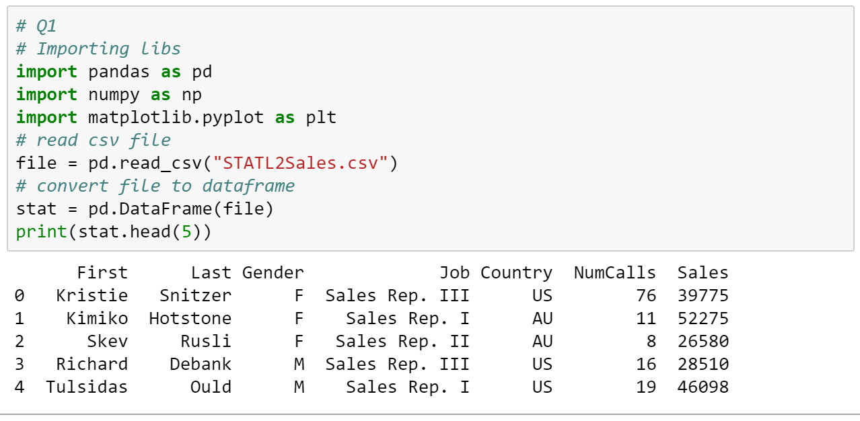

1. Create a correlation matrix of the quantitative variables

**Insert a screenshot of your code and output.**

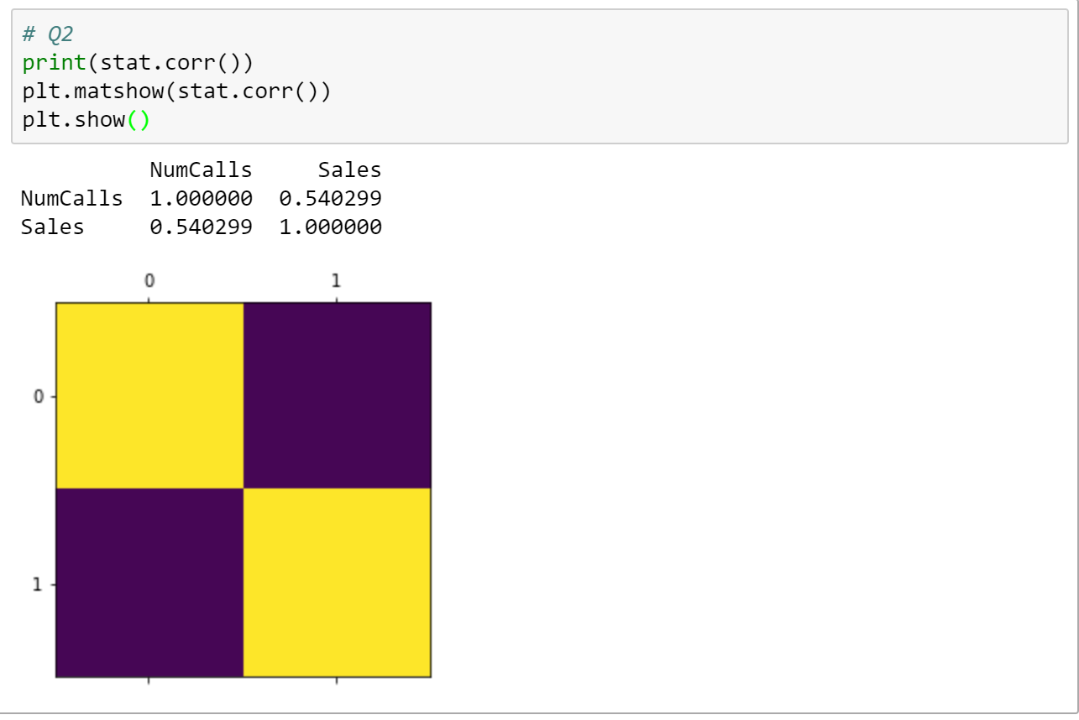

1. Create a scatterplot of NumCalls vs. Sales. Put the correlation in the graph title.

**Insert a screenshot of your code and output.**

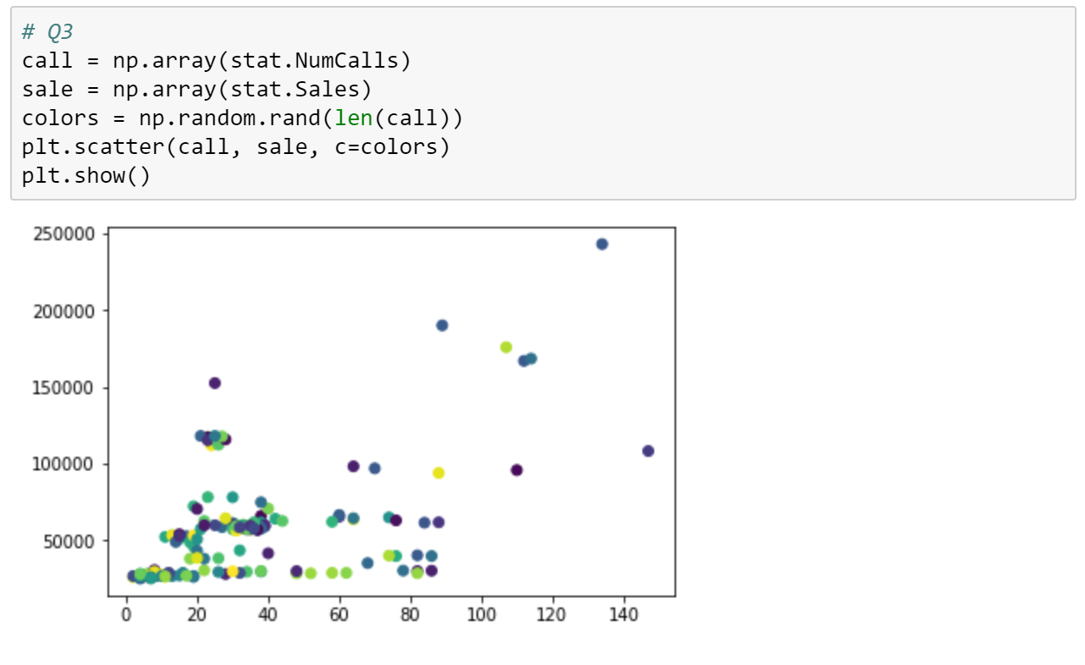

1. Create a scatterplot of the Sales Rep I rows with NumCalls vs. Sales. Color these dots red. Add a second series to this plot for the Sales Rep II people with blue dots. Make sure you have an appropriate legend, x and y axis labels, and title. Put the correlation for Rep I data and for Rep II data on the plot.

**Insert a screenshot of your code and output.**

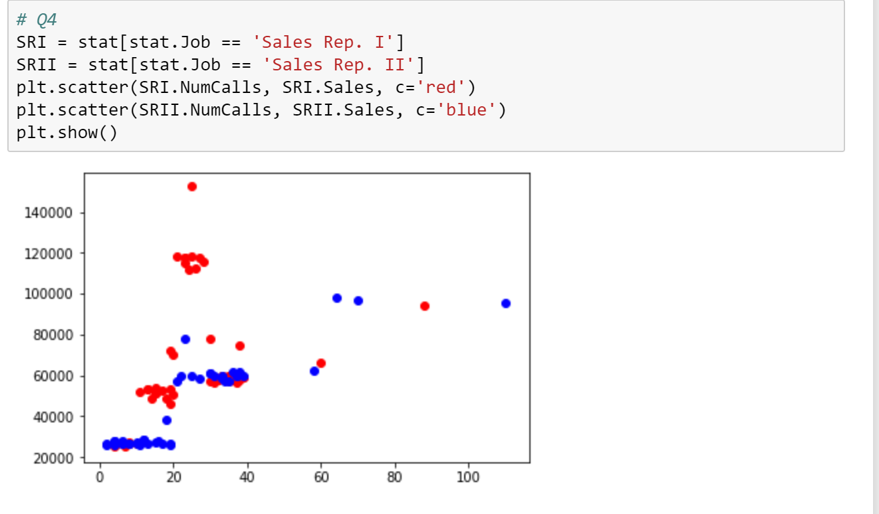

1. Create a 2 x 2 subplot comparing the histograms of all 4 sales reps Sales. Make sure to include appropriate titling/labels.

**Insert a screenshot**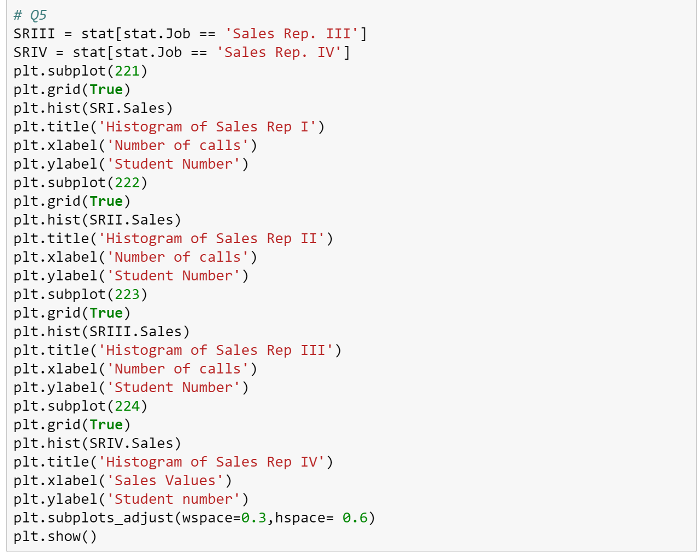

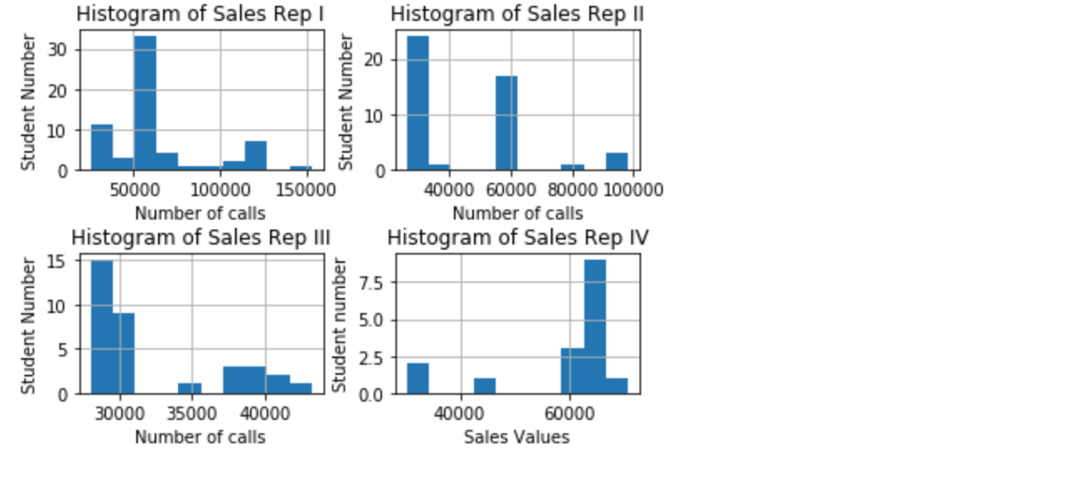

1. Using groupby, calculate the mean sales grouped by Country.

**Insert a screenshot of your code and output.**

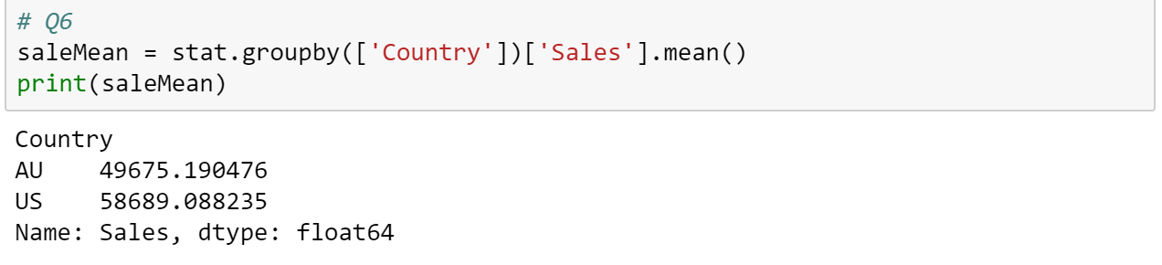

1. Using groupby, calculate the count for each Job Type.

**Insert a screenshot of your code and output.**

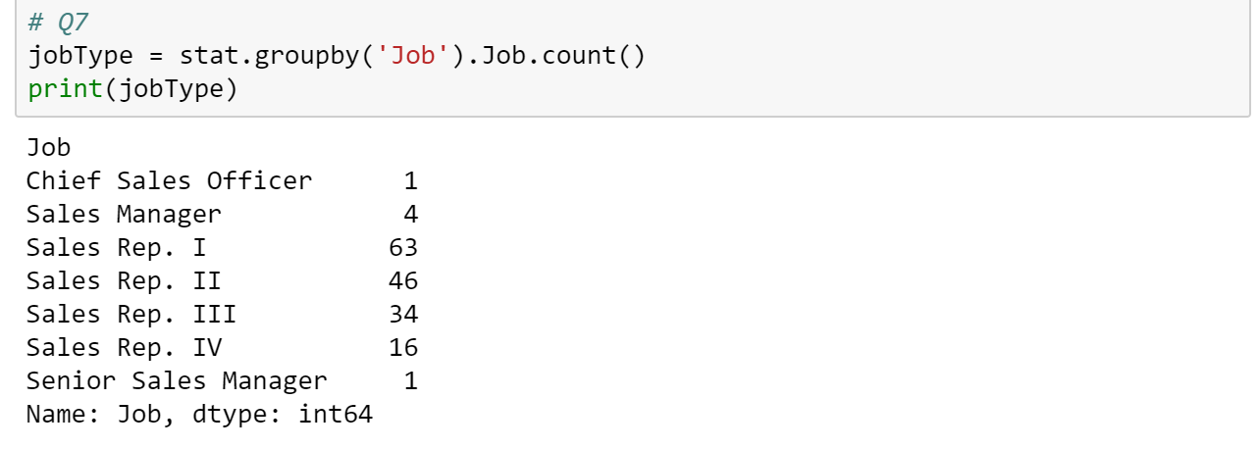

1. Using Groupby, calculate the mean Sales grouped by Job Type and Gender. Unstack this so that the second index is a column instead of a second index.

**Insert a screenshot of your code and output.**

